1. **How many times less secure is this (in theory vs in practice)?**
   1. This is 3.6 x 10^18 times less secure in practice compared to in theory.
2. **Functional code submitted to Canvas.**
   1. Attached.
3. **What is k1 and k2?**

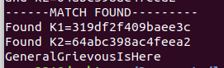

* 1. K1: 319df2f409baee3c
  2. K2: 64abc398ac4feea2

1. **What is the secret message?** 
   1. GeneralGreviousIsHere
2. **Encrypt the plaintext 371c using the same key of 6b5d.**

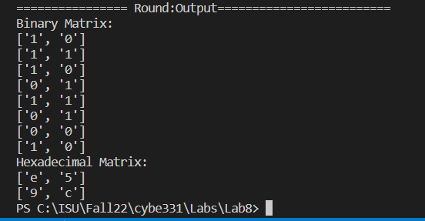

1. **Functional code submitted to Canvas.**
   1. Attached